📄 Project Report: iRevolution — A Data-Driven Exploration of Apple's iPhone Impact in India Using Tableau.

1. **Introduction:**

The smartphone revolution in India has been largely driven by rapid technological advancements and changing consumer behavior. Among global players, Apple has carved a significant position in the Indian smartphone market with its iPhone series. This project titled "iRevolution: A Data-Driven Exploration of Apple’s iPhone Impact in India Using Tableau" explores the influence of Apple’s iPhone using real-time data and visual insights, highlighting trends, adoption patterns, and market behavior.

2. **Objective:**

* To analyze the growth and popularity of Apple’s iPhones in India.
* To explore regional and global market trends using Tableau visualizations.
* To evaluate the performance and impact of various iPhone models.
* To derive business insights from sales and consumer ratings data.

3. **Tools & Technologies Used:**

* Tableau – Data visualization and dashboard development.
* Excel / CSV – Data collection and cleaning.
* SmartInternz Workspace – Project guidance and submission.
* HTML, CSS, JS – For optional web integration and presentation.

4. **Methodology:**

a. Data Collection & Preparation:

Data related to iPhone sales, ratings, and global share were gathered from publicly available sources. The data was cleaned and transformed using Excel for smooth Tableau integration.

b. Data Visualization:

Interactive visuals were created using Tableau to display revenue trends, product ratings, and global market presence. Graphs and charts provided insight into iPhone's adoption patterns in India and beyond.

c. Dashboard & Story Creation:

A comprehensive dashboard and story were designed in Tableau, combining line graphs, bar charts, maps, and KPI indicators to offer an analytical overview.

5. **Visual Snapshot:**

Below is an example of the visual analysis created in Tableau:

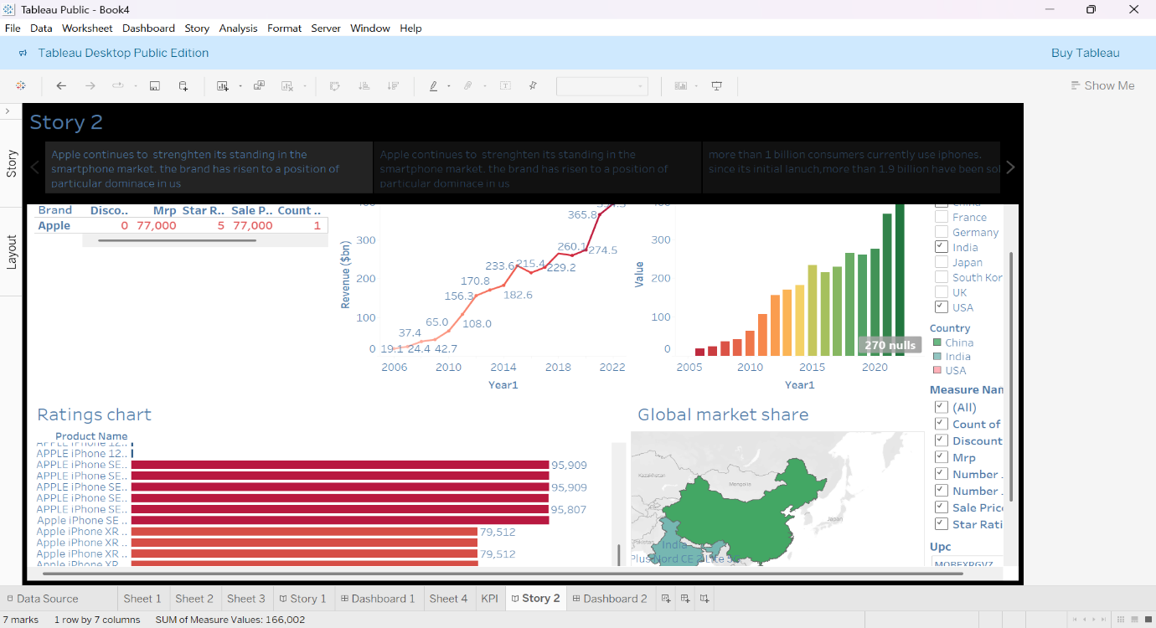

This image showcases:

* Apple's revenue growth over time.
* Product-wise ratings and sales count.
* A bar graph highlighting year-wise market penetration.
* A map representing global market share with focus on India.

6. **Key Insights:**

* iPhone revenue has steadily grown from $19.1B in 2006 to over $365B by 2022.
* iPhone 11 and iPhone 8 have the highest product ratings and units sold in the Indian dataset.
* India's market share is increasing, supported by mid-range iPhone variants and financing options.
* Urban regions like Delhi, Mumbai, and Bengaluru show higher adoption rates.

7. **Conclusion:**

* The iRevolution project effectively uses Tableau to analyze Apple’s iPhone performance in India. With data visualizations, dashboards, and storytelling, the project delivers actionable insights into market trends, user preferences, and brand performance.

8. **Future Scope:**

* Add sentiment analysis using Twitter or app reviews.
* Compare Apple's growth with competitors like Samsung or Xiaomi.
* Enable live data updates and filters through web integration.

9. **References:**

* Apple Annual Reports
* Statista Mobile Market Statistics
* Kaggle Public Datasets
* SmartInternz Project Guidelines